September 17, 2022
Unami Monthly Meeting 100 East Fifth Street Pennsburg, PA 18073

Unami Monthly Meeting
of the Religious Society of Friends

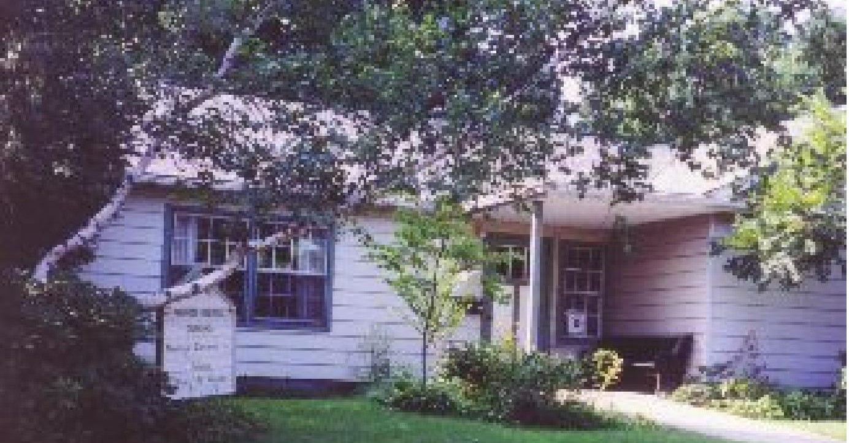

Calendar

This Month:

Sept. 18, Meeting for Worship, 11 a.m. (Hybrid)

Sept. 25,Apologies and Forgiveness Workshop
9:30am - 10:45 a.m., Meeting for Worship, 11
a.m. (Hybrid)
Future:

Oct. 8, Unami Work Day 9 a.m. - Noon
Oct. 9, Meeting for worship with a concern for business, 9 a.m, Meeting for Worship, 11 a.m. (Hybrid)

Oct. 23, The Struggles and Joys of Trans Youth,9:30 a.m. -10:30 a.m.,

October 30, Tradition of Sharing Twilight Thoughts, 9:30 a.m. -10:30 a.m

November 20, Reunion of Unami Friends, 12:30 p.m.

Newsletter Deadline
The deadline for the next newsletter is Oct. 14 at 4 PM. This is a Thursday deadline.
Send your news to danielhazelton@rcn.com.

MESSAGE FROM THE PROPERTY COMMITTEE.

With apologies for late notice the Property Committee is inviting Friends to join in a Work Day at Unami on SATURDAY OCTOBER 8th from 9am-noon. If you are unable to attend on that day we will be posting
a list of tasks for which you can sign up at a time convenient for you.

The projects that are currently on our list are as follows:

CLEAN and “Flex Seal?” Gutter.
SCRAPE rear trim on windows and apply primer coat. RAKE and remove leaves.
GENERAL indoor cleaning.
WINDOWS cleaned and screens removed. CUT DOWN Redbud in front of building.
SIGN WORK. Remove two top pieces, sand and paint. WEED east bank on Macoby street.
SHADE (or curtain) work on two southern windows. UPDATE LIGHTBULBS to LED’s as needed throughout building.

Randy Quinby, Property Committee

Unami Meeting for Worship, Discussion, and Meeting
for Worship with a Concern for Business

We’re open, again!

With joy and thanksgiving we open the meetinghouse to you. Out of respect for those vulnerable among us to a COVID infection or ineligible to receive a vaccination at this time, we require masks to be worn at the beginning of all meetings at the meetinghouse (except toddlers and babies). If you’ve forgotten your mask, please help yourself to one on the foyer table. After the start of the meeting the convenor will ask if any of the attendees are uncomfortable with masks being removed. If all are comfortable then masks may optionally be removed during the meet- ing.

In the meetinghouse, we are using OWL technology to provide a Zoom link to those friends wor- shiping at a distance so that we can all be in the same room of the Spirit. Sit wherever you want, respecting social distance.

If you have a message, please move to the seat with a print scarf draped over it so that the OWL can pick up your message and broadcast it. Feel free to remove your mask in order to be heard clearly; thank you for replacing it after you speak.

At close of meeting before the pandemic, our tradition has been to shake hands and some to hug. At present, some of us bow and greet each other at a distance, some elbow bump. Please do what you feel is safe for you and expect that however clumsily we greet each other at close, we are nevertheless expressing peace and goodwill. We will routinely introduce ourselves so that all on Zoom or in the meetinghouse can be one gathered community.

We will have a program for children on the third and fourth Sundays of each month. Please contact First Day School committee member Linda Weinberger if you plan to bring your chil- dren at any other time. Your children are welcome in the meeting room for the first 15 minutes of worship as you choose. After that, someone will rise to usher them out for activities indoors or outside.

Meeting for Worship with a Concern for Business begins in hybrid form on every second Sunday at 9 a.m., starting again in September, followed by Meeting for Worship at the usual time: 11:00 a.m.

If you would like to join us by Zoom, contact us at unamifriendsmeeting@gmail.com

Unami Monthly Meeting Events September - November 2022

September 25, 9:30am - 10:45 a.m. Apologies and Forgiveness Workshop led by Marietta Quinby

Friends are asked to consider and share their history of offering apologies. How have we approached these moments? Can we improve on how we do this?

October 23, 9:30am - 10:45 a.m. The Struggles and Joys of Trans* Youth, led by Max Probst and Rae Davis. Childcare will be provided.

Join us in an engaging dialogue about the struggles and joys of being young and trans*. Young people from our local community will share their experiences and we will discuss the sociological ramifications of current legislation that targets trans* people in schools, in sports, and society in general. From banning books to “Don’t Say Gay” (and whatever else comes up between now and then), join us in conversation about the state of affairs for trans* people.

October 30, 9:30am – 10:45 a.m. Tradition of Sharing Twilight Thoughts

Discussion led by Joyce Moore and Philip Donnelly on the history, challenges, and opportunities of Unami Meeting’s tradition of sharing “Twilight” thoughts at the rise of meeting. The discussion will include consideration of how Friends discern if they offer a vocal message during meeting for worship.

November 20, 12:30pm - Reunion of Unami Friends

Remembering the birth of Unami Meeting 50 years ago. We will be reaching out to all those who have been a part of Unami Meeting and hope you will help in spreading the word!

September 25, 9:30am - Apologies and Forgiveness Workshop led by Marietta Quinby

Friends are asked to consider and share their history of offering apologies. How have we approached these moments? Can we improve on how we do this?

Essential Questions: Why should we take responsibility for our actions that have harmed others or hurt their feelings? What makes an apology sincere? What is the power of forgiveness?

Preparation: Read the Role-Play cards below. Consider how you could improve on one or more of these. Be prepared to offer your ‘improved’ apology at the workshop.

Consider the essential parts of a sincere apology. 1) Say what happened. 2) Say how what you did was hurtful. 3) Say how the incident made the other person feel. 4) Offer to make amends for what you did.

If time permits, we will use Quaker dialogue to offer what we have learned from the workshop. Role-Play Cards:
- You borrowed you friend’s favorite CD and accidentally scratched it. “Sorry about the CD. I’d buy you a new one but I’m broke.”
- Your best friend told you a secret, and you told it to another friend, who then spread it around. “Sorry but you should have told me you didn’t want me to tell anyone.”
- A long-time friend is acting hurt because you are spending time with a new friend. “What, can’t I have other friends?”
- You’ve been slacking off on your chores and it has been hard on your Mom. “Sorry about the dishes. I was tired, too.”
- You had an argument with your brother and said some things that hurt him. “I’m sorry I hurt you, but you sometimes say things that hurt me too.”
- Your friend is avoiding you after you pressured her to break up with her boyfriend. “Hey, I was only looking out for you.”
- You made a nasty remark about a guy’s haircut and he wants to fight you now. “I didn’t mean it like that. Can’t you take a joke?”
- Your best friend is irritated because you have again bought the same clothes that he or she did. “We just like the same things. I can’t help it if you buy them first. You have more money than I do.”
- You broke a date with a friend because another friend was sad and needed someone to talk to. “I’m sorry. If you were bummed wouldn’t you want me to drop everything and help you?”
- You stay up late and your track coach is disappointed in your race time the next day. “Don’t worry; I’ll do better next time.”
- You made fun of a kid last year and feel badly about your behavior now. “Sorry I was such a (blankety-blank) last year.”

October 23, 9:30am - The Struggles and Joys of Trans* Youth, led by Max Probst and Rae Davis.
Childcare will be provided.

Join us in an engaging dialogue about the struggles and joys of being young and trans*. Young people from our local community will share their experiences and we will discuss the sociological ramifications of current legislation that targets trans* people in schools, in sports, and society in general. From banning books to “Don’t Say Gay” (and whatever else comes up between now and then), join us in conversation about the state of affairs for trans* people.

*trans is used here as an inclusive term for our transgender and gender diverse population that includes a diverse range of identities

Max Probst has been teaching Sociology at Bucks County Community College since 2009. He has served as the faculty advisor to the Open Door Club (the College’s LGBTQ+ student organization) where he has worked closely with students to bring advocacy, community, and resources to the college. Max looks forward to teaching the recently developed course, “Introduction to Queer Studies” in Spring 2023.

Rae Davis (they/them) is an educator, activist, and record-loving friend to all LGBTQ+ youth, Rae is a Community Health Educator and the founder and director of Roy G. Biv Doylestown & facilitator for the Rainbow Room Doylestown. Rae started Roy
G. Biv Doylestown while working at Siren Records to fulfill the need for LGBTQ+ youth ages 10-14 to have an environment that fosters creativity, support, and education amongst like-minded kiddos.

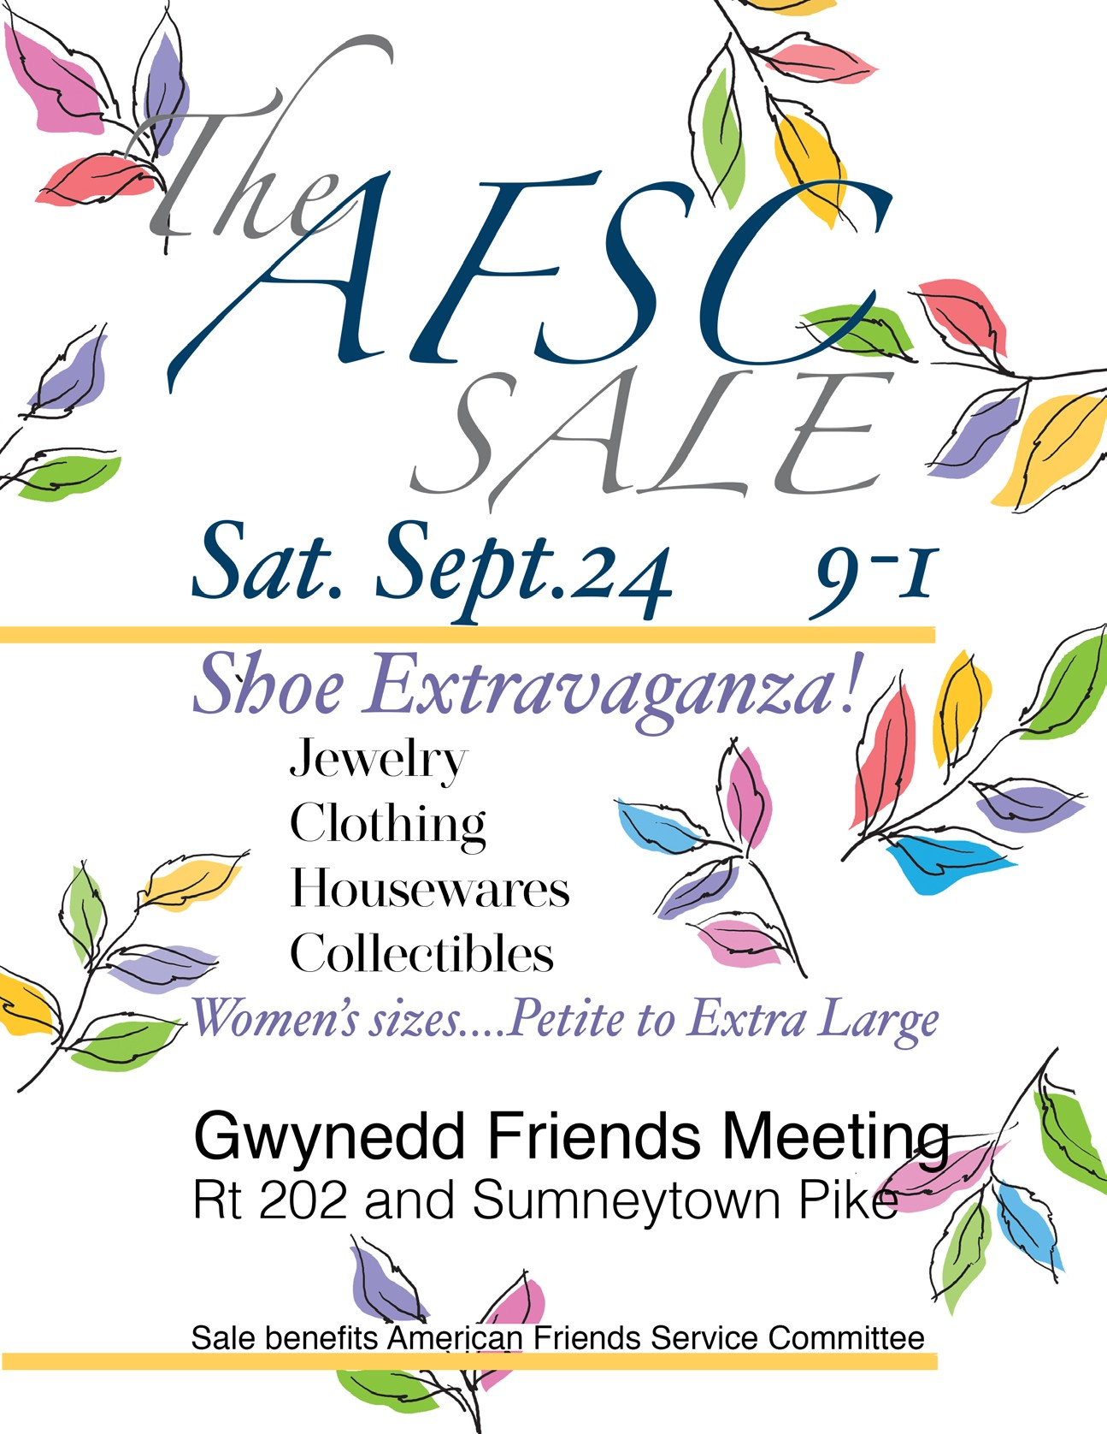

Please add to your calendars Saturday, September 24, 2022, for the next AFSC Flea Market. The sale is 9-1 at Gwynedd Friends (across William Penn Inn and Foulkeways). We are looking for donations of complete puzzles (meaning ALL pieces included) and fun board games. There will be plenty of excellent quality shoes and women’s clothing available to start your Fall season wardrobe off right! Also, houseware and jewelry. If you like to volunteer or donate games/puzzles, please contact:
Chris Mrozinski, Abington Quarterly Meeting (Quakers) Newsletter Editor christophermrozinski@gmail.com
215-237-6648

sign up for the free showing of

FIGHTING INDIANS
on Sunday, Oct 2, from 4:30-6:00
https://gmu.zoom.us/webinar/register/WN_zgx201qfRDu-70EjXJSQwA

This is a rare opportunity to see a FREE screening of this important documentary.

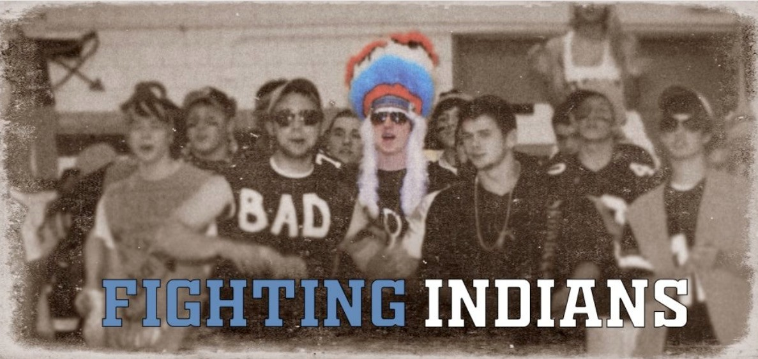

FCNL: Take Action Tell Congress to Protect Voting Rights https://fcnl.quorum.us/campaign/37250/?utm_source=fcnlaction

Coalition for Natives and Allies Film – Fighting Indians
PLEASE MARK YOUR CALENDARS FOR: SUNDAY, OCT 2, FROM 4:30-6:00
https://www.coalitionofnativesandallies.org/

AQM Enabling Fund and AQM Fund Assistance

The Abington Quarterly Meeting has determined that for Unami Friends who are members or who are active attenders who may be needing short term financial assistance during this difficult time, funds are available from the Abington Quarter Meeting Enabling Fund for all members and from the AQM Fund for all active attenders.

For more information contact:
Rebecca Cratin, the Administrator of the Home and Care Committee, 215-542-8738
rhcratin@cratin.com or
Marietta Quinby, representative from Unami to the Home and Care Committee 215-257-4895
rmquinby@verizon.net
or
Lynn Biddle, Unami’s Care of Members Committee clerk
267-377-6560
lcbiddle@hotmail.com

Query for the Month of September

Witnessing in the World: Education
- What does our meeting do to support and improve public education?
- What help do we provide for the children and adults in our meeting to pursue their educational goals?
- What is our meeting’s role in support for Friends’ education? If our meeting is connected to a Friends school or schools, does this relationship nurture spiritual life and the manifestation of Friends principles?
- Do we enable children in our meeting to attend a Friends school? Does our meeting work with the family to consider all available means of support?
- How do I show my concern for the improvement of public education in my community?
- Do I demonstrate my encouragement and support for Friends education through awareness and service?

