January 14, 2023
Unami Monthly Meeting 100 East Fifth Street Pennsburg, PA 18073

Unami Monthly Meeting
of the Religious Society of Friends

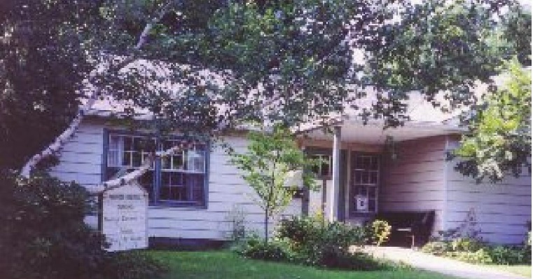

Message from the Treasurer
Calendar
This Month

Jan. 15, Meeting for Worship, 11 a.m. Jan. 22, Meeting for Worship, 11 a.m.
Jan. 29, Discussion on UU Hysterical Society video led by Robin, 9:30 a.m., Meeting for Worship, 11 a.m.
Future:

Feb. 5, Meeting for Worship, 11 a.m.
Feb. 12, Meeting for worship with a concern for business, 9 a.m, Meeting for Worship, 11 a.m.

Unami Meeting has maintained a stable financial position in 2022 however, we are recognizing a trend toward increased expenses related to an aging building at the same time that we are witnessing a declining number of contributors. Our membership has remained stable in the past few years but the number of donors has decreased. It is a trend that raises concern.

Every donation is important to the future of Unami as we work to strengthen and deepen our roots in our beloved communities both near and far. Please remember Unami as you consider your charitable contributions in 2023.

Newsletter Deadline
The deadline for the next newsletter is Feb. 16 at 4 PM. This is a Thursday deadline.
Send your news to danielhazelton@rcn.com.
As we enter a new year, I am mindful that some Friends may wish to have a report of their
contributions for tax purposes. Please contact me if you would like to receive a report of your recorded contributions for 2022.

AQM Enabling Fund and AQM Fund Assistance

The Abington Quarterly Meeting has determined that for Unami Friends who are members or who are active attenders who may be needing short term financial assistance during this difficult time, funds are available from the Abington Quarter Meeting Enabling Fund for all members and from the AQM Fund for all active attenders.

For more information contact:
Rebecca Cratin, the Administrator of the Home and Care Committee, 215-542-8738
rhcratin@cratin.com or
Marietta Quinby, representative from Unami to the Home and Care Committee 215-257-4895
rmquinby@verizon.net
or
Lynn Biddle, Unami’s Care of Members Committee clerk
267-377-6560
lcbiddle@hotmail.com

Query for the Month of January
Deepening Our Faith: Spiritual Nurture
- How does the meeting encourage the use of spiritual practices that deepen our faith, enhance the excitement of shared religious discovery and increase the possibility of spiritual transformation?
- What is the nature of our shared experience of the Divine and how do we nurture our collective spiritual growth and transformation?
- In what ways do we support each other in our spiritual journeys, in our search for God’s will and in our efforts to increase understanding of humanity’s relationship to life on earth?
- How do we recognize, develop and nurture the spiritual gifts of all in our meeting?
- How do I incorporate into my personal and family life those daily practices that focus on continued spiritual growth, including worship, reflection and engagement with writings that nurture the soul?
- How does my spiritual life integrate an understanding of a well-ordered relationship with the earth and deepen my reverence for the interconnectedness of all life?

Worship and Ministry Announcements

Discussion January 29, 9:30 – Robyn will lead a discussion after we gather and view a 4-1/2 minute video from the UU (Unitarian Universalist) Hysterical Society. Our discussion will center around the final question in the video which invites a personal response that we will share with one another. The video is available for advanced viewing (recommended but not required) at the following link: https://www.youtube.com/watch?v=baF3I5ur7YY.

While we are working to develop future discussions, Friends on the Worship and Ministry Committee are always open to suggestions on subjects for our Sunday discussions. Please contact any of the committee members to offer these suggestions.

HOORAY!! Unami’s new website is live!!! Go to https://www.unamiquakers.org
Let the Outreach Committee know what you think.

Mary Hanisch Nancy Donnelly

2022 State of Unami Meeting Report

In preparing to write this report, I assembled all of the minutes and newsletters of the past year, a ”practice against forgetfulness” that I hope will sustain us at Unami Meeting. I was surprised to remember that we hadn’t met in person during the months of January, February, and most of March because of COVID variant outbreaks. Perhaps, it was because it seemed so long ago, or perhaps, it was because our eventual transition to hybrid meetings appeared smooth and effortless, thanks to the efforts of a few. In spite of COVID, The Unami community has remained engaged and vibrant.

Although our membership numbers have remained the same, we have seen some new families at Meeting including some from United Friends School. Later this fall, Meeting for Business decided to lay aside our practice of Twilight for a period of 4 months beginning in January 2023 to see if and how it affected vocal ministry at Meeting for Worship. We have moved to using a Consent Agenda for our previous month’s Meeting for Worship with a Concern for Business Minutes approval and the practice seems to be effective. As has historically been the case at Unami, members have risen to meet the financial needs of the meeting as they present themselves.

Committees were actively engaged in their work throughout the year, meeting both by Zoom and in person. Over a period of several months’ discussions, we decided to limit terms for all Committee appointments to 2 consecutive 3 year terms. The Worship and Ministry Committee led us in meaningful discussions that enrich our spiritual lives. They asked us to consider the practice of Twilight after Meeting, explore the Peace Testimony, and reflect on authentic apologies. Their planning and preparation for our first in-person Seasonal Celebration since December of 2019 was a huge success! In the summer, we participated in three “Against Forgetting” Writing Workshops.

The Peace and Social Concerns committee continued to look for ways for us to address, both individually and collectively, reparations for African Americans and Native Americans, developed a list of black owned businesses in the area, and organized a discussion on Trans Youth. The Carbon Forest Committee became a standing “Ad Hoc” Committee and with Unami and community members is working to secure land and funding for this carbon sequestration project. The relationship of the Carbon Forest Committee to Unami was spelled out in an approved Memorandum of Agreement. The Young Friends Committee continued to connect with our children while we were meeting remotely and opened First Day School in person near the end of March. They continue to look for ways to engage children each week, offering regular programming on the last 2 Sundays of the month. They have encouraged all of us to get our clearances so that we can all be more fully engaged with our Young Friends.

The Care and Membership Committee continues its work of oversight and nurturing of our Unami community. The reactivated Outreach Committee is helping to make Unami more visible to our greater community and is pleased to announce the debut of Unami’s new website in the days to come. The Property Committee keeps our building in good repair and looks for ways to improve our comfort, energy efficiency, and visibility to our community.

Unami continues its “care relationship” with United Friends School and has provided two members to the UFS Board of Trustees. We look for ways to engage the UFS community in Unami’s activities and have invited school families to several of our discussions and celebrations.

In November, thanks to the efforts of the Worship and Ministry and Care and Membership Committees, Unami celebrated its 50th anniversary with a reunion of old and new Friends. It was a wonderful gathering in person and on Zoom of local and faraway Friends. We were reminded of the history of Unami Meeting, which arose out of an interest in the late 60’s and early 70’s among U.S. Quakers to participate in a vital, transformative lifestyle that melded spirit-filled worship with social action. The original members sought to create a community where all would be welcome and in this our 51st year, we continue to be a strong spiritual community where issues of social justice are seriously considered with action, and all are welcome.

Respectfully, Nancy Donnelly,

Jim D’Amato

Jim D’Amato transferred into Unami Meeting in 2008. He was a person deeply concerned about justice and peace. He is remembered for his ready laugh, friendliness, and dedication to his wife, Sandy, during her convalescence. In 2020, grieving his wife’s death, he left us to find a spiritual home in his wife’s denomination. Here is his obituary. https://www.huffandlakjer.com/obituary/james-damato

Unami Meeting for Worship, Discussion, and Meeting for Worship with a Concern for Business

We’re open, again!

With joy and thanksgiving, we open the meetinghouse to you. Out of respect for those vulnerable among us to a COVID infection or ineligible to receive a vaccination at this time, we require masks to be worn at the beginning of all meetings at the meetinghouse (except toddlers and babies). If you’ve forgotten your mask, please help yourself to one on the foyer table. After the start of the meeting the convenor will ask if any of the attendees are uncomfortable with masks being removed. If all are comfortable then masks may optionally be removed during the meet- ing.

In the meetinghouse, we are using OWL technology to provide a Zoom link to those friends
worshiping at a distance so that we can all be in the same room of the Spirit. Sit wherever you want, respecting social distance.

If you have a message, please move to the seat with a print scarf draped over it so that the OWL can pick up your message and broadcast it. Feel free to remove your mask in order to be heard clearly; thank you for replacing it after you speak.

At close of meeting before the pandemic, our tradition has been to shake hands and some to hug. At present, some of us bow and greet each other at a distance, some elbow bump. Please do what you feel is safe for you and expect that however clumsily we greet each other at close, we are nevertheless expressing peace and goodwill. We will routinely introduce ourselves so that all on Zoom or in the meetinghouse can be one gathered community.

We will have a program for children on the third and fourth Sundays of each month. Please contact First Day School committee member Linda Weinberger if you plan to bring your
children at any other time. Your children are welcome in the meeting room for the first 15 minutes of worship as you choose. After that, someone will rise to usher them out for activities indoors or outside.

Meeting for Worship with a Concern for Business begins in hybrid form is on every second Sun- day at 9 a.m., followed by Meeting for Worship at the usual time: 11:00 a.m.

Please contact us at unamifriendsmeeting@gmail.com if you would like to join us by Zoom.

